# LAB MANAGEMENT SYSTEM

MINI PROJECT REPORT

Submitted by

**ARUN GEORGE**

**PTA21CS020**

**DEEPU KOCHUMON**

**PTA21CS024**

**JIBIL JOSEPH**

**PTA21CS033**

# JISSIN SAM MATHEW

**PTA21CS035**

## to

*the APJ Abdul Kalam Technological University*

*in partial fulfilment of the requirements for the award of the*

*Degree of Bachelor of Technology in Computer Science and*

*Engineering*



**Department of Computer Science & Engineering**

College of Engineering

Kallooppara Pathanamthitta

April 2024

# DECLARATION

We undersigned hereby declare that the project report **LAB MANAGEMENT SYSTEM** submitted for partial fulfilment of the requirements for the award of degree of Bachelor of Technology of the APJ Abdul Kalam Technological University,Kerala is a bonafide work done by us under supervision of **Mrs.Anitha Jose** and **Mrs.Athira S,** department of Computer Science And Engineering, College of Engineering Kallooppara**.** This submission represents our ideas in our own words and ideas or words of others have been included where we have adequately and accurately cited and referenced the original sources. We also declare that we have adhered to ethics of academic honesty and integrity and have not misrepresented or fabricated any data or idea or fact or source in our submission. We understand that any violation of the above will be a cause for disciplinary action by the institute and/or the university and can also evoke penal action from the sources which have thus not been properly cited or from whom proper permission has not been obtained. This report has not been previously formed the basis for the award of any degree, diploma or similar title of any other university.

Place Kallooppara ARUN GEORGE

Date: 08/04/2024 DEEPU KOCHUMON

JIBIL JOSEPH

JISSIN SAM MATHEW

# DEPARTMENT OF COMPUTER SCIENCE &

# ENGINEERING COLLEGE OF

# ENGINEERING KALLOOPPARA

# PATHANAMTHITTA- 689603



# CERTIFICATE

This is to certify that the project design report entitled ‘ **Lab Management System ’**

submitted by **Arun George** (PTA21CS020), **Deepu Kochumon** (PTA21CS024),

**Jibil Jospeh** (PTA21CS033), **Jissin Sam Mathew** (PTA21CS035) in partial fulfillment with the requirements of the award of the Degree of Bachelor of Technology in Computer Science and Engineering of APJ Abdul Kalam Technological University is a bonafide work carried out by them under our guidance and supervision.The report in any form has not been submitted to any other University or Institute for any purpose.

|  |  |  |  |  |
| --- | --- | --- | --- | --- |
| **Coordinator**    **Mrs. Anitha Jose** |  | **Internal Guide**  **Mrs. Athira S** |  | **Head of The Department**  **Dr. Renu George** |
| Assistant Professor, |  | Assistant Professor, |  | Assistant Professor, |
| Department of |  | Department of |  | Department of |
| Computer Science & |  | Computer Science & |  | Computer Science & |
| Engineering |  | Engineering |  | Engineering |

# ACKNOWLEDGEMENT

We would like to take this opportunity to acknowledge everyone involved in the creation and development of this project.We express our utmost gratitude to **Dr.Nisha Kuruvilla**, The Principal, College Of Engineering Kallooppara, **Dr.Renu George**, Head of Department, Computer Science And Engineering, College Of Engineering Kallooppara for providing us the required support and assistance.We would also like to take this opportunity to express our gratefulness to **Mrs. Anitha Jose** and **Mrs. Athira S**, department of Computer Science And Engineering, College of Engineering Kallooppara for providing us the tools and support we needed. We also want to acknowledge the efforts of our seminar guide **Mrs. Athira S**, Computer Science and Engineering,College of Engineering Kallooppara and her utmost support and proclivity for our project.

Finally we wish to thank the families of each of the members involved and everyone who showed their kindness and support for our work along the way.

ARUN GEORGE

DEEPU KOCHUMON

JIBIL JOSEPH

JISSIN SAM MATHEW

# ABSTRACT

The **Computer Lab Management System** proposed in this project serves as a comprehensive solution aimed at optimizing the efficiency and effectiveness of computer lab sessions for both students and faculty. With a focus on addressing critical aspects such as lab schedules, curriculum coverage, attendance tracking, student feedback, and faculty communication, this system introduces innovative features tailored to enhance the overall learning experience.

Key features of the system include detailed lab schedules, providing students with essential information on session dates, lab subjects, and covered portions, empowering them to prepare effectively. Real-time attendance tracking functionality ensures accountability by allowing faculty to monitor student participation and enabling students to track their attendance records conveniently.

To enhance coding programs, the system offers a dedicated section highlighting common errors encountered during lab sessions, facilitating student understanding and error rectification for an improved learning experience. Furthermore, a student review mechanism enables continuous improvement through daily feedback on lab sessions, allowing faculty to adapt teaching methods to meet student needs effectively.

The system's faculty dashboard streamlines administrative tasks by providing real-time data on attendance, curriculum coverage, and viva marks. Additionally, seamless communication between faculty and students is facilitated through targeted messaging features, enhancing transparency and ensuring timely information dissemination.

In conclusion, the Computer Lab Management System presented herein aims to create a harmonious and efficient learning environment by addressing key aspects such as schedules, attendance, coding errors, student feedback, and faculty communication. By leveraging technology and innovative features, this system seeks to enhance the collaborative and effective nature of computer lab experiences, ultimately fostering higher student satisfaction and academic success.

**CONTENTS**

**ACKNOWLEDGMENT ........................................................................................................ I**

**ABSTRACT ....................................................................................................................... II CONTENTS ......................................................................................................................... III**

**LIST OF TABLES ................................................................................................................IV**

**LIST OF FIGURES ............................................................................................................. V ABBREVIATIONS .............................................................................................................. VI**

## CHAPTER 1 INTRODUCTION .............................................................................................. 1

1.1 Objective .................................................................................................................... 2

1.2 Scope ......................................................................................................................... 2

**CHAPTER 2 LITERATURE SURVEY ................................................................................. 3**

**CHAPTER 3 PROBLEM STATEMENT .............................................................................. 4**

3.1 Description of the problem .............................................................................................. 4

## CHAPTER 4 PROPOSED SYSTEM ..................................................................................... 5

4.1 Description………………………………………………………………………… 5

4.2 Functionality……………………………………………………………………… 5

4.3 Stakeholders……………………………………………………………………… 11

4.4 Block diagram …………………………………………………………………… 11

4.5 Environment ……………………………………………………………………… 12

4.6 System Requirements……………………………………………………………… 13

**CHAPTER 5 DESIGN DIAGRAM ......................................................................................... 16**

5.1 ER diagram .................................................................................................................. 16

5.2 Database……………………………………………………………………………….17

5.3 Data Flow Diagram ...................................................................................................... 18

5.4 Usecase Diagram………………….………………………………………….………..19

**CHAPTER 6 CONCLUSION.................................................................................................... 20**

**REFERENCES ........................................................................................................................... 21**

# LIST OF TABLES

**NO TITLE PAGE NO.**

4.6.1 HARDWARE REQUIREMENTS 13

4.6.2 SOFTWARE REQUIREMENTS 13

**LIST OF FIGURES**

# NO TITLE PAGE NO

6

4.2.1 FACULTY LOGIN

6

4.2.2 STUDENT LOGIN

4.2.3 FACULTY HOMEPAGE 7

4.2.4 FACULTY COURSE DIARY 7

8

4.2.5 CHAT AND FEEDBACK SECTION

4.2.6 STUDENT HOME PAGE 8

4.2.7 STUDENT MARK SECTION 9

4.2.8 CHAT AND FEEDBACK SECTION 9

4.2.9 PASSWORD CHANGE SECTION 10

4.4.1 BLOCK DIAGRAM 11

5.1 ER DIAGRAM 16

5.2 DATABASE 17

5.3 DATAFLOW DIAGRAM 18

5.4 USECASE DIAGRAM 19

# ABBREVIATIONS

* LMS : Lab Management System

* HTML : Hyper Text Markup Language

* CSS : Cascading Style Sheets
* SQLite : Structured Query Language Lite. SQL is a standard language for storing, manipulating and retrieving data in database

**CHAPTER 1**

**INTRODUCTION**

# 1.1 BACKGROUND

In today's educational landscape, efficient management of computer lab facilities is crucial due to the growing reliance on technology. Traditional methods of lab management are inadequate, necessitating a comprehensive Computer Lab Management System (LMS) to address modern challenges.

The proposed LMS aims to optimize lab schedules, streamline attendance tracking, facilitate student feedback, and enhance communication between faculty and students. Key features include detailed lab schedules, real-time attendance tracking, error analysis tools, student feedback mechanisms, and a faculty dashboard.

By providing a centralized platform for managing all aspects of computer lab sessions, the CLMS promotes efficiency, transparency, and collaboration. Its development is essential for meeting the evolving needs of students and faculty in today's digital age, ultimately enhancing the learning experience for all stakeholders.

The system's emphasis on automation and technology integration ensures that administrative tasks are simplified, allowing faculty to focus more on teaching and student engagement. Additionally, the LMS fosters a data-driven approach to decision-making, enabling institutions to adapt quickly to changing educational requirements and improve overall academic outcomes.

Furthermore, the LMS offers scalability and flexibility to accommodate the diverse needs of different educational institutions, ranging from small colleges to large universities. Its user-friendly interface and intuitive design make it accessible to both faculty and students, promoting widespread adoption and usage across campus.

In conclusion, the development and implementation of a robust Computer Lab Management System represent a significant step forward in enhancing the efficiency and effectiveness of computer lab sessions. By leveraging technology and innovation, the CLMS empowers educational institutions to deliver a superior learning experience and stay ahead in today's competitive academic environment.

# 1.1 OBJECTIVE

The objective of the Lab Management System project is to develop a comprehensive software solution that optimizes computer lab management within educational institutions. The system aims to streamline lab scheduling, automate attendance tracking, facilitate student feedback collection, and enhance communication between faculty and students.

Additionally, the system will provide insights into lab utilization, student engagement, and curriculum coverage, enabling data-driven decision-making for continuous improvement. By fostering a culture of innovation and collaboration, the system seeks to create a conducive learning environment that promotes academic success and institutional excellence.

# 1.2 SCOPE

The scope of a Lab management system is broad and encompasses multiple aspects of the Faculty and Student. Some key areas that fall within the scope of the system include:

1. Lab Scheduling: Efficient scheduling of lab sessions to optimize resource allocation and enhance the utilization of lab facilities.
2. Attendance Tracking: Automated tracking of student attendance to ensure accountability and facilitate data-driven decision-making.
3. Student Feedback Collection: Collection of feedback from students regarding lab sessions, curriculum coverage, and overall learning experience to drive continuous improvement.
4. Error Analysis and Improvement: Integration of tools for error analysis in coding programs to aid students in understanding and rectifying coding mistakes, thereby enhancing their learning experience.
5. Administrative Tasks: Streamlining of administrative tasks for faculty, including curriculum management, assessment tracking, and reporting functionalities.

# CHAPTER-2

# LITERATURE SURVEY

1. **"A Review of Lab Management System Techniques"** by Ananya Patel, Rajesh Kumar, and Neha Sharma. This review article summarizes the techniques used for lab management system, including scheduling optimization, attendance tracking, and student feedback analysis. It also discusses the challenges of lab management system implementation and future research directions.
2. **"Lab Management System: A Comprehensive Review"** by Rahul Singh, Priya Gupta, and Rakesh Sharma. This study provides a comprehensive review of lab management systems, including their functionalities, benefits, challenges, and best practices. It also discusses the role of technology in lab management system implementation and provides a case study of a lab management system implementation.
3. **"Student Feedback Management: A Review and Framework for Analysis in Lab Management Systems**" by Meena Suresh, Sneha Patel, and Karthik Reddy. This article reviews the literature on student feedback management in lab management systems and proposes a framework for analyzing student feedback data. The framework includes three stages: feedback collection, analysis, and implementation.
4. **"Lab Feedback Management: A Framework and Research Agenda"** by Priyanka Sharma, Vishal Jain, and Neha Gupta. This article proposes a framework for lab feedback management that includes three key stages: feedback collection, analysis, and implementation. The authors argue that effective lab management requires a holistic approach that integrates student feedback with other sources of information, such as faculty input and curriculum design.

In summary, the literature on lab management systems underscores the significance of student feedback in optimizing lab sessions and fostering academic excellence. It also illuminates the hurdles in analyzing feedback effectively and underscores the pivotal role of technology in surmounting these obstacles. Future research avenues may involve refining analytical techniques for student feedback and seamlessly integrating lab management systems with agile educaitional purposes.

**CHAPTER-3**

**PROBLEM STATEMENT**

## 3.1 THE PROBLEM

The challenge addressed by our Lab Management System (LMS) lies in the ineffective management and utilization of resources in computer lab environments within educational institutions. Despite the crucial role of labs in facilitating hands-on learning experiences, traditional methods of lab management often lack efficiency and coordination.

Lab sessions involve intricate scheduling, attendance tracking, and feedback collection processes, which are often handled manually or through disjointed systems. This leads to inefficiencies in resource allocation, inconsistencies in attendance records, and limited avenues for student engagement and feedback.Moreover, faculty members may encounter difficulties in analyzing feedback and identifying areas for improvement due to the absence of structured approaches and collaboration tools. As a result, valuable insights from students may go unnoticed, hindering the enhancement of lab sessions and overall learning outcomes.

Our Lab Management System aims to tackle these challenges by providing educational institutions with a centralized platform for streamlined management of lab sessions. By leveraging technology and data-driven insights, our system empowers faculty and administrators to optimize scheduling, automate attendance tracking, and facilitate seamless communication with students.

Through comprehensive feedback collection and analysis functionalities, the system enables educators to gain valuable insights into student experiences and preferences. This facilitates informed decision-making and targeted improvements to enhance the quality of lab sessions and promote student success.

# CHAPTER-4

# PROPOSED SYSTEM

## 4.1 DESCRIPTION

## The Lab Management System (LMS) streamlines lab scheduling, automates attendance tracking, and facilitates student engagement within educational institutions. It aims to optimize resource utilization and enhance the learning experience by providing centralized scheduling mechanisms and real-time attendance insights. Additionally, the system fosters seamless communication between faculty and students, enabling effective dissemination of information and promoting collaboration. Incorporating feedback collection mechanisms, the LMS systematically captures student insights to identify areas for improvement and tailor lab sessions accordingly. In summary, the LMS offers a comprehensive solution to enhance the efficiency and effectiveness of lab sessions, ultimately contributing to academic success.

## 4.2 FUNCTIONALITY

The Lab Management System (LMS) streamlines lab scheduling, automates attendance tracking, and enhances student engagement within educational institutions. Key features include:

1. Resource Management: Efficient Scheduling and Allocation of lab resources,optimizing sessions based on the curriculum requirements and student needs.
2. Attendance Tracking: Automated processes for tracking student attendance, providing real-time insights and ensuring accountability.
3. Student Engagement: Facilitation of communication between faculty and students, fostering collaboration and providing feedback submission channels.
4. Collaboration: Enables faculty collaboration to discuss and resolve issues related to lab sessions, curriculum coverage, and student feedback.
5. Privacy and Security: Prioritizes data privacy and security, ensuring appropriate handling of sensitive student information.
6. Features Marks: Incorporates a "Features Marks" section to display daily marks or progress, allowing faculty to track student performance and provide timely feedback. This feature enhances the monitoring of student progress and supports continuous improvement in the learning process.

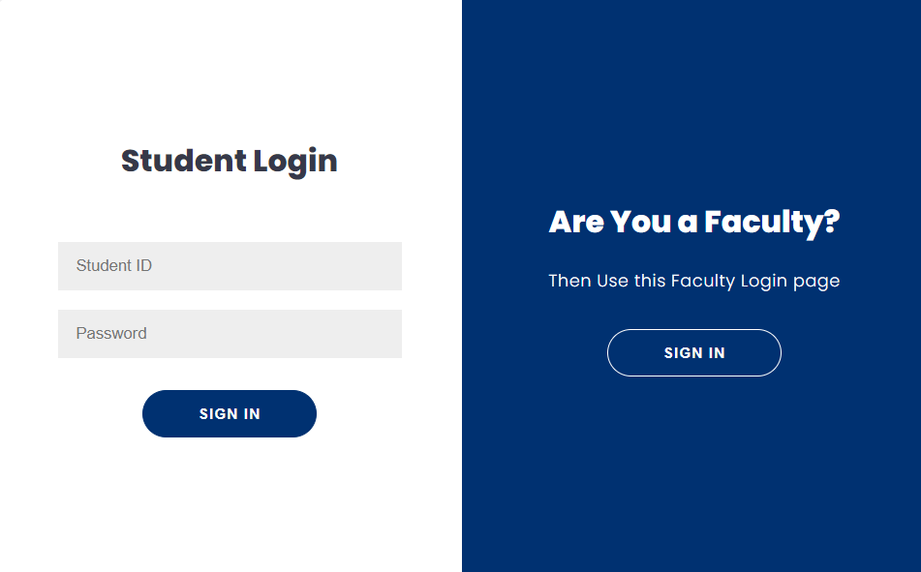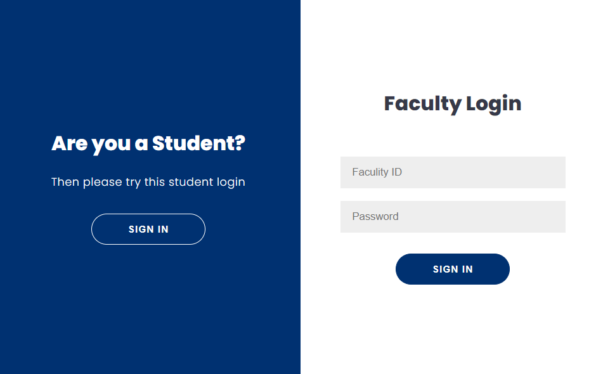

### **4.2.1** Faculty Login(Fig)

**4.2.2** Student Login (Fig)

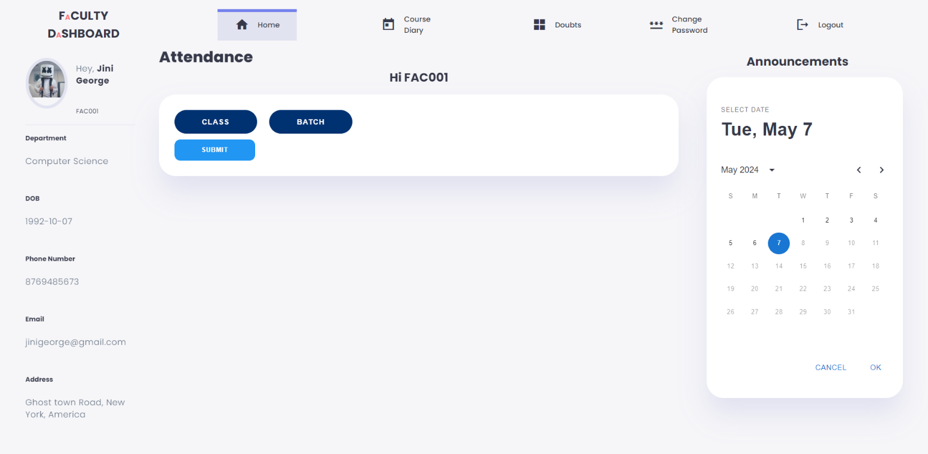

### 4.2.3.Faculty HomePage (Fig)

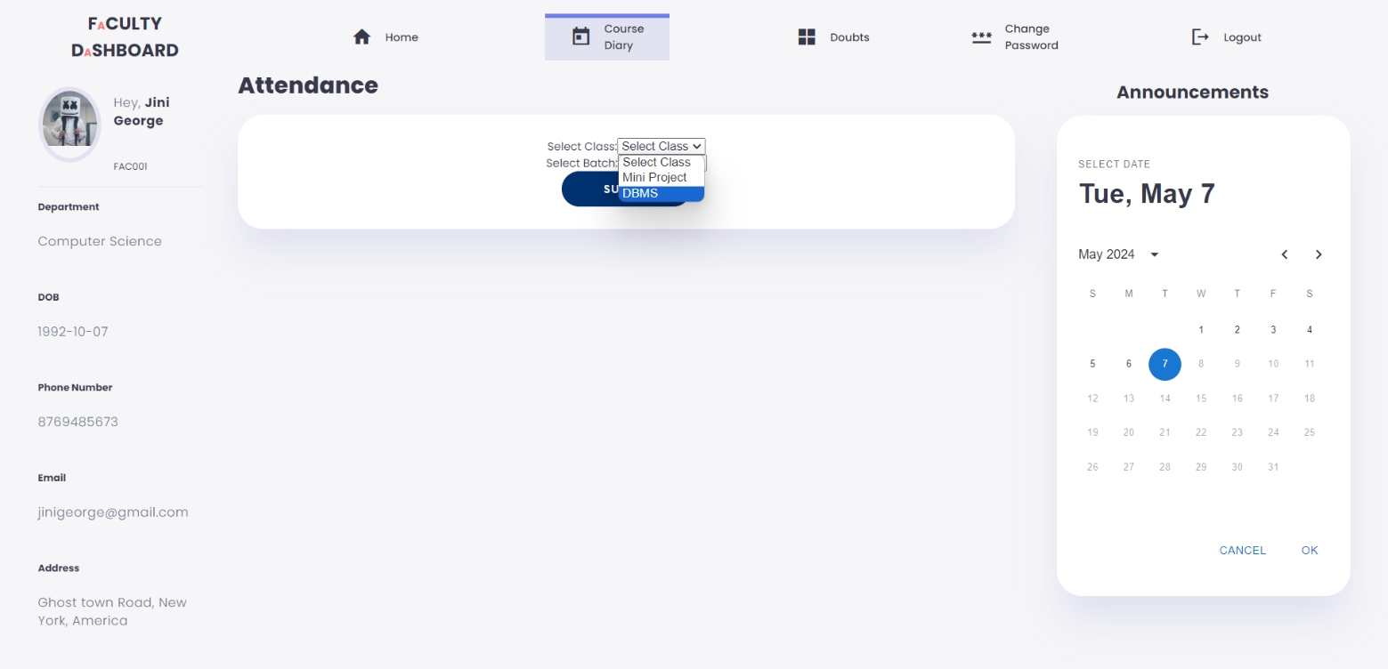

### 4.2.4. Faculty Course Diary (Fig)

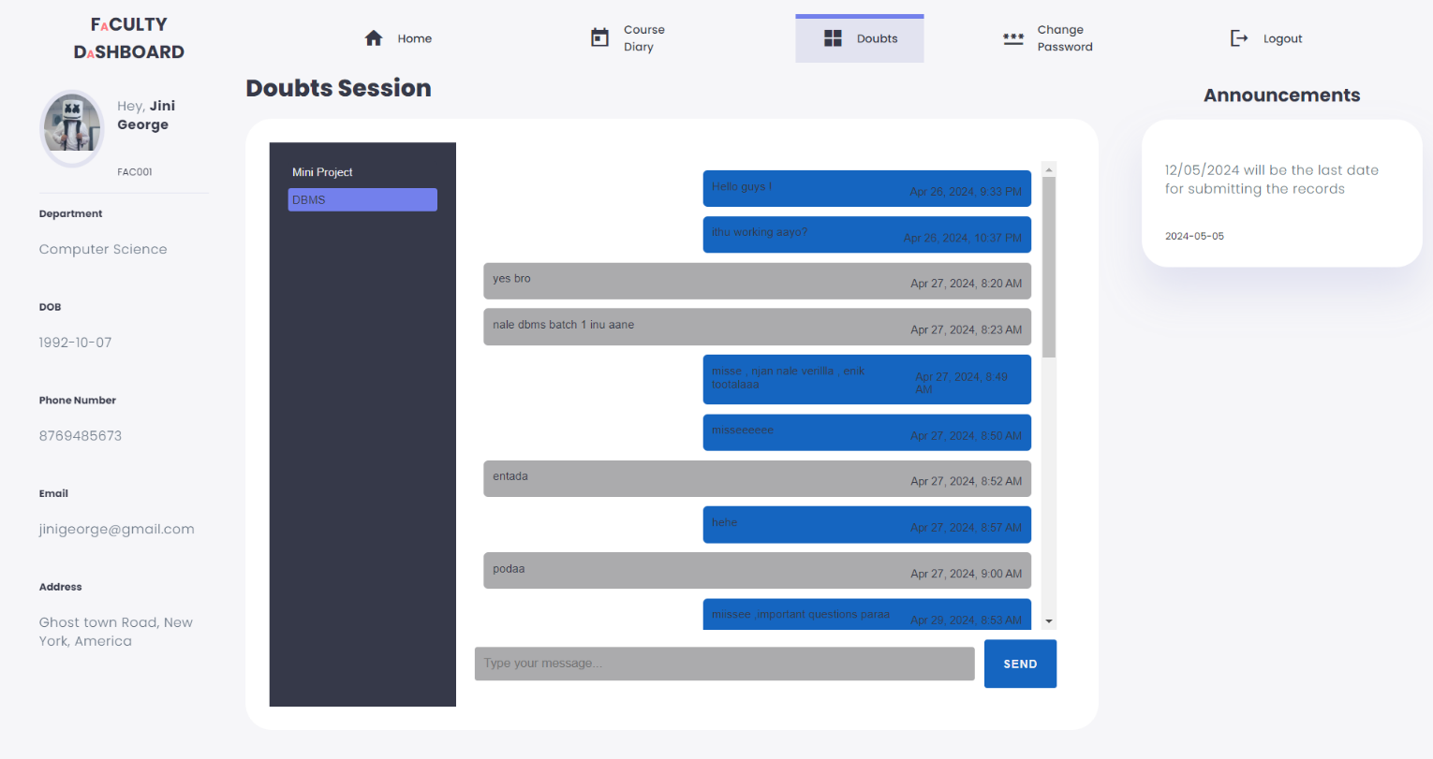

### 4.2.5. Faculty Chat & Feedback Section (Fig)

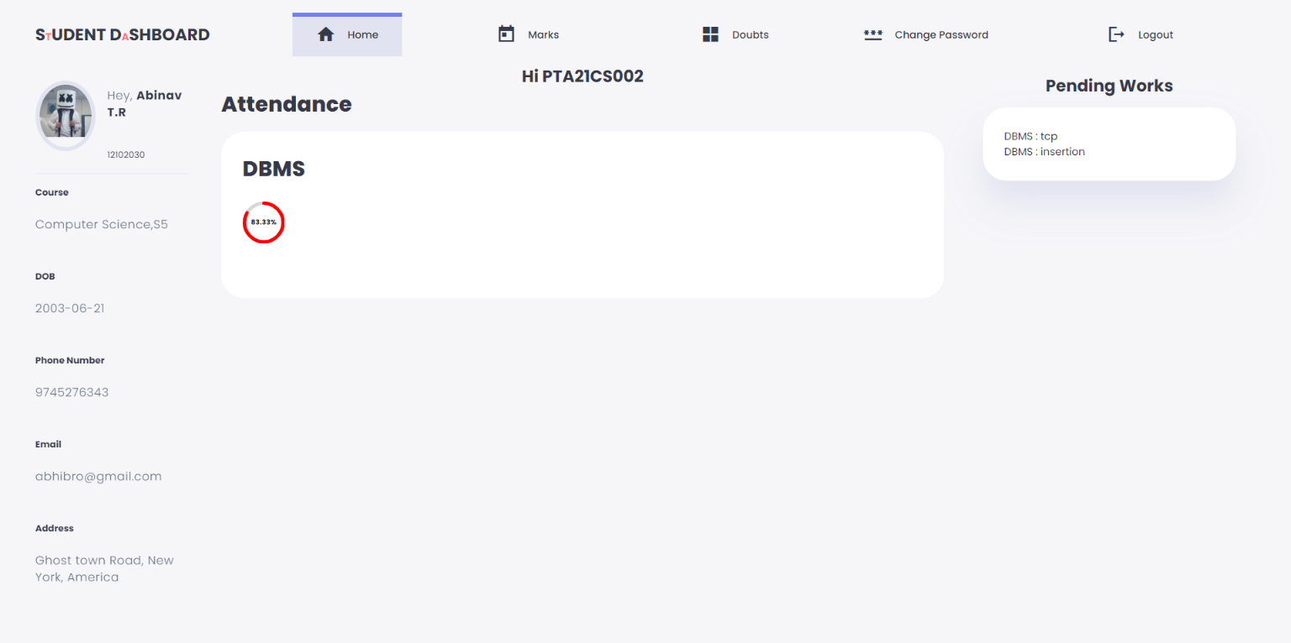

### 4.2.6. Student Home Page (Fig)

### A screenshot of a computer Description automatically generated4.2.7.Student Mark Section (Fig)

4.2.8.Student Doubt and FeedBack section (Fig)

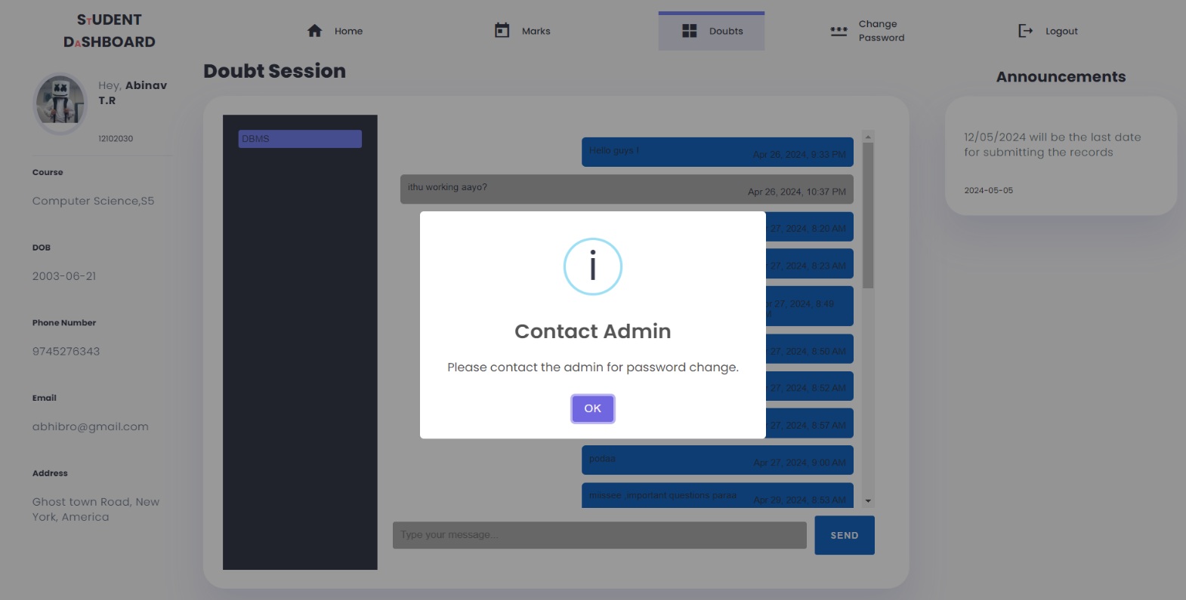

4.2.9. Password Change Section (Fig)

## 4.3 STAKEHOLDERS

The stakeholders of our Lab Management System (LMS) typically include:

1. Faculty and Instructors: They provide valuable insights and feedback on the effectiveness of lab sessions, curriculum coverage, and student engagement.
2. Students: They play a crucial role in providing feedback on their learning experiences, lab facilities, and overall satisfaction with the system.
3. IT Administrators: They are responsible for the implementation, maintenance, and technical support of the LMS, ensuring its smooth operation and security.
4. Academic Administrators: They oversee the overall academic operations and may use the feedback collected through the LMS to make decisions regarding curriculum enhancements and resource allocation.
5. Software Developers: They are involved in the development and enhancement of the LMS, incorporating feedback from stakeholders to improve its functionality and usability

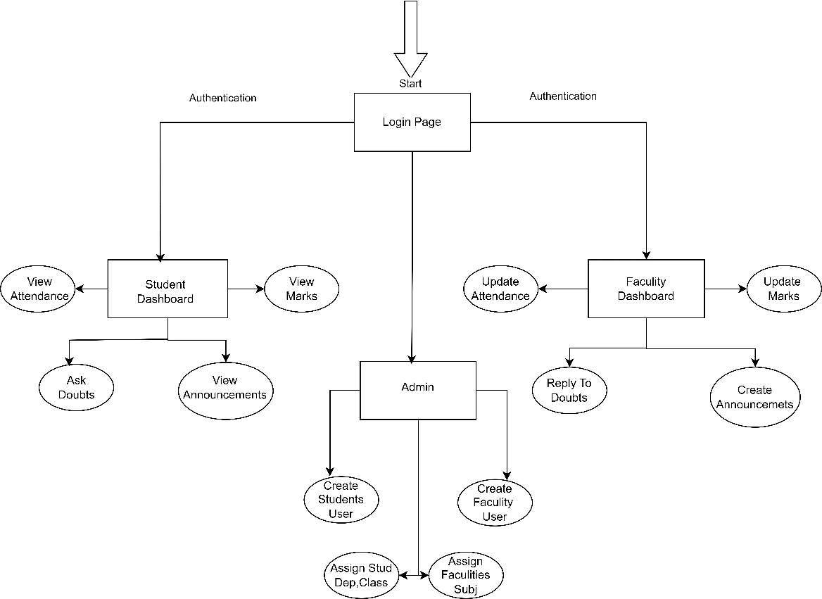 **4.4 BLOCK DIAGRAM**

Fig 4.4.1 Block diagram

## 4.5 ENVIRONMENT

The common environments for deploying lab management systems include:

1. Web-Based Platform: A lab management system deployed on a web-based platform can be accessed through standard web browsers such as Chrome, Edge, and Firefox. This platform offers the advantage of accessibility from any device with internet connectivity, enabling stakeholders to easily submit and review feedback.
2. Database: The lab management system utilizes MD5 encryption along with SQL for database queries, ensuring secure storage and retrieval of data.
3. Responsive Design: The system features a responsive design, making it compatible with various screen sizes and devices, including desktops, laptops, tablets, and mobile phones. This ensures an optimal viewing experience for users across different devices.

## 4.6 SYSTEM REQUIREMENTS

### **4.6.1 Hardware**

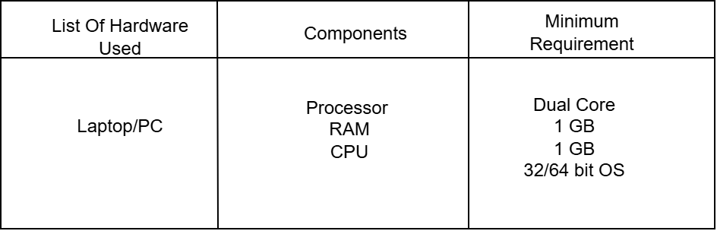

### **Table 4.6.1** Hardware Requirements

### **4.6.2 Software**

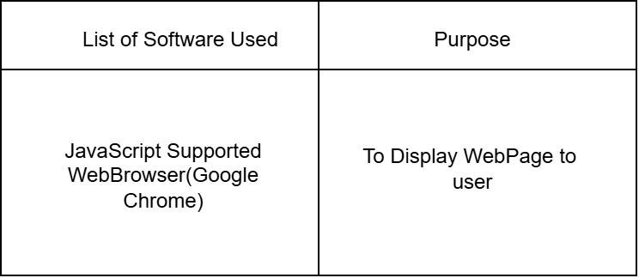

**Table 4.6.2** Software Requirements

## REACT

React, a JavaScript library developed by Facebook, is widely used for building dynamic UI components for web applications. It enables developers to create efficient UIs that adapt to changing data. React follows a component-based architecture, making it easy to manage complex applications. One key feature is its virtual DOM, which minimizes DOM manipulations for faster rendering speeds. React promotes a declarative programming style, simplifying development and maintenance. It seamlessly integrates with other libraries like Redux and React Router for state management and routing, providing developers with a flexible solution for modern web apps.

Top of Form

## CSS

Cascading Style Sheets (CSS) is a [style sheet language u](https://en.wikipedia.org/wiki/Style_sheet_language)sed for describing the [presentation o](https://en.wikipedia.org/wiki/Presentation_semantics)f a document written in a [markup language s](https://en.wikipedia.org/wiki/Markup_language)uch as [HTML o](https://en.wikipedia.org/wiki/HTML)r [XML (](https://en.wikipedia.org/wiki/XML)including XML dialects such as [SVG,](https://en.wikipedia.org/wiki/Scalable_Vector_Graphics) [MathML o](https://en.wikipedia.org/wiki/MathML)r [XHTML)](https://en.wikipedia.org/wiki/XHTML).CSS is a cornerstone technology of the [World Wide Web,](https://en.wikipedia.org/wiki/World_Wide_Web) alongside HTML and [JavaScript.](https://en.wikipedia.org/wiki/JavaScript)CSS is designed to enable the [separation of content and presentation,](https://en.wikipedia.org/wiki/Separation_of_content_and_presentation) including [layout,](https://en.wikipedia.org/wiki/Page_layout) [colors,](https://en.wikipedia.org/wiki/Color) and [fonts.](https://en.wikipedia.org/wiki/Typeface) This separation can improve content [accessibility;](https://en.wikipedia.org/wiki/Accessibility) provide more flexibility and control in the specification of presentation characteristics; enable multiple [web pages t](https://en.wikipedia.org/wiki/Web_page)o share formatting by specifying the relevant CSS in a separate .css file, which reduces complexity and repetition in the structural content; and enable the .css file to be [cached t](https://en.wikipedia.org/wiki/Cache_(computing))o improve the page load speed between the pages that share the file and its formatting.Separation of formatting and content also makes it possible to present the same markup page in different styles for different rendering methods, such as on-screen, in print, by voice (via speech-based browser or [screen reader)](https://en.wikipedia.org/wiki/Screen_reader), and on [Braille-based](https://en.wikipedia.org/wiki/Braille_display) tactile devices. CSS also has rules for alternate formatting if the content is accessed on a [mobile device.](https://en.wikipedia.org/wiki/Mobile_device)

## JAVASCRIPT

JavaScript , often abbreviated as JS, is a [programming language](https://en.wikipedia.org/wiki/Programming_language) that is one of the core technologies of the [World Wide Web, a](https://en.wikipedia.org/wiki/World_Wide_Web)longside [HTML a](https://en.wikipedia.org/wiki/HTML)nd [CSS.](https://en.wikipedia.org/wiki/CSS) As of 2022, 98% of [websites](https://en.wikipedia.org/wiki/Website) use JavaScript on the [client s](https://en.wikipedia.org/wiki/Client_(computing))ide for [webpage b](https://en.wikipedia.org/wiki/Web_page)ehavior, often incorporating third-party [libraries.](https://en.wikipedia.org/wiki/Library_(computing)) All major [web browsers](https://en.wikipedia.org/wiki/Web_browser) have a dedicated [JavaScript engine](https://en.wikipedia.org/wiki/JavaScript_engine) to execute the [code](https://en.wikipedia.org/wiki/Source_code) on [users'](https://en.wikipedia.org/wiki/User_(computing)) devices.

JavaScript is a [high-level,](https://en.wikipedia.org/wiki/High-level_programming_language) It has [dynamic typing,](https://en.wikipedia.org/wiki/Dynamic_typing) [prototype-based](https://en.wikipedia.org/wiki/Prototype-based_programming) [object-orientation,](https://en.wikipedia.org/wiki/Object-oriented_programming) and [first- class functions.](https://en.wikipedia.org/wiki/First-class_function) It is [multi-paradigm,](https://en.wikipedia.org/wiki/Programming_paradigm) supporting [event-driven,](https://en.wikipedia.org/wiki/Event-driven_programming) [functional,](https://en.wikipedia.org/wiki/Functional_programming) and [imperative](https://en.wikipedia.org/wiki/Imperative_programming) [programming styles.](https://en.wikipedia.org/wiki/Programming_paradigm) It has [application programming interfaces (](https://en.wikipedia.org/wiki/Application_programming_interface)APIs) for working with text, dates, [regular expressions,](https://en.wikipedia.org/wiki/Regular_expression) standard [data structures,](https://en.wikipedia.org/wiki/Data_structure) and the [Document Object Model (](https://en.wikipedia.org/wiki/Document_Object_Model)DOM).

JavaScript is a powerful programming language primarily used for web development. It allows developers to add dynamic and interactive elements to websites, making them more engaging and user-friendly.With JavaScript, you can manipulate the content of web pages, handle user interactions, and create responsive web applications.JavaScript offers a rich set of built-in functions and objects that simplify common tasks, such as manipulating the DOM (Document Object Model), making AJAX (Asynchronous JavaScript and XML) requests, and performing form validations. It also supports object-oriented programming principles, allowing developers to create reusable code and modular structures.

**DJANGO**

Django, a high-level Python web framework, facilitates rapid development of web applications with a clean and pragmatic design. It follows the Model-View-Template (MVT) architectural pattern, where developers define models to represent data, views to handle user requests, and templates to generate HTML responses. One of Django's key features is its built-in administration interface, which automatically generates CRUD (Create, Read, Update, Delete) interfaces for models. Django also emphasizes security, providing built-in protection against common security threats such as SQL injection, cross-site scripting (XSS), and cross-site request forgery (CSRF). Moreover, Django promotes code reusability and maintainability through its modular design and extensive documentation. It encourages best practices like DRY (Don't Repeat Yourself) and convention over configuration, allowing developers to focus on building features rather than boilerplate code. Furthermore, Django offers a rich ecosystem of third-party packages, known as "Django apps," which extend its functionality for tasks like user authentication, content management, and API development. In summary, Django empowers developers to build robust, secure, and scalable web applications efficiently, thanks to its comprehensive feature set, clean design, and vibrant community support.

**CHAPTER-5**

# DESIGN DIAGRAM

## 5.1 ER DIAGRAM

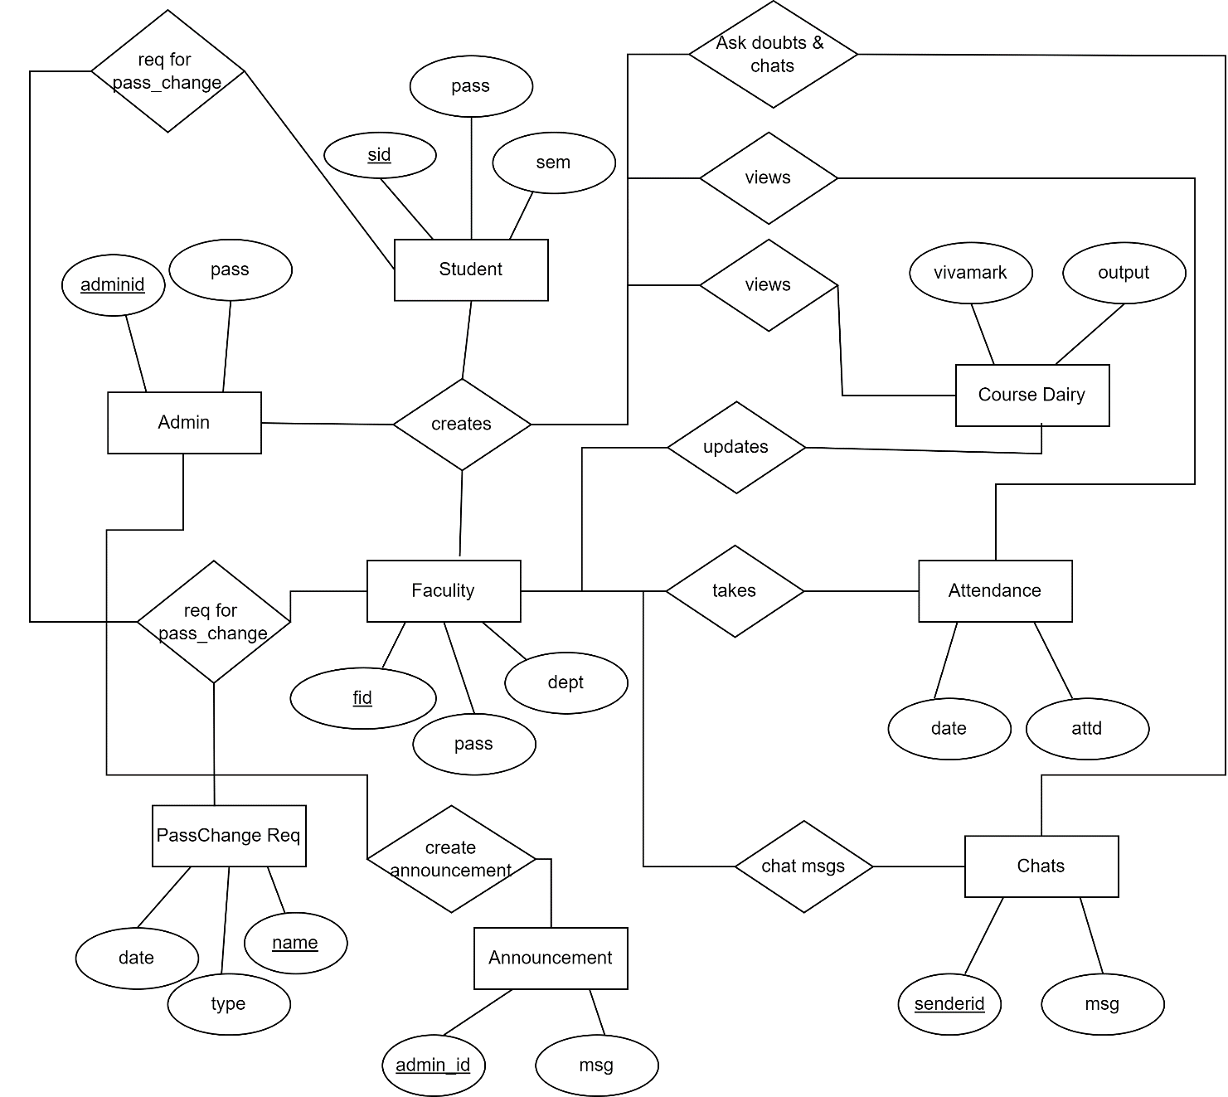

## 5.2 DATABASE

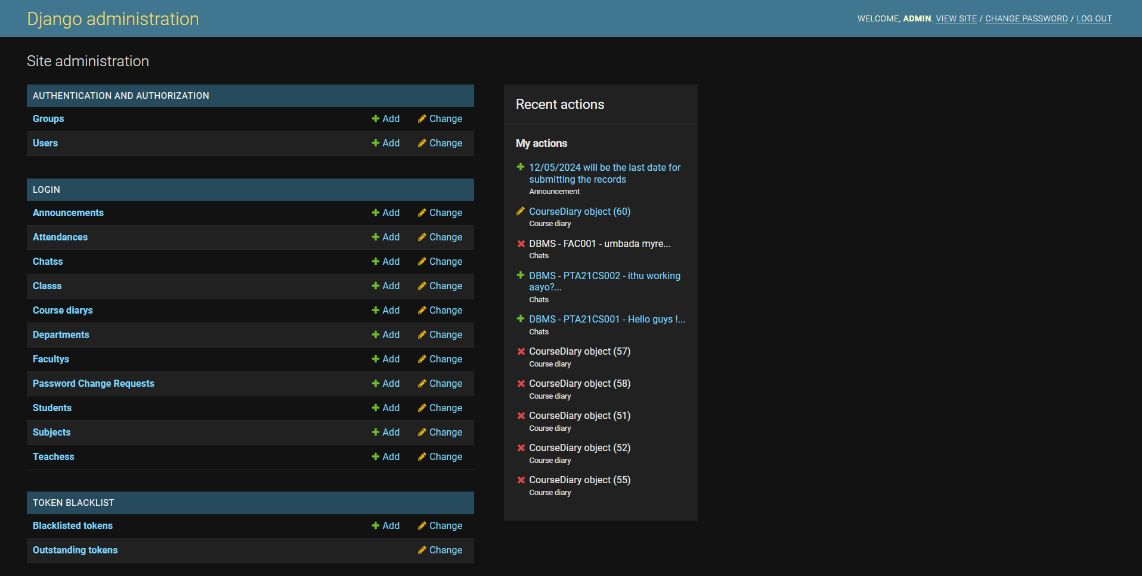

## DATAFLOW DIAGRAM

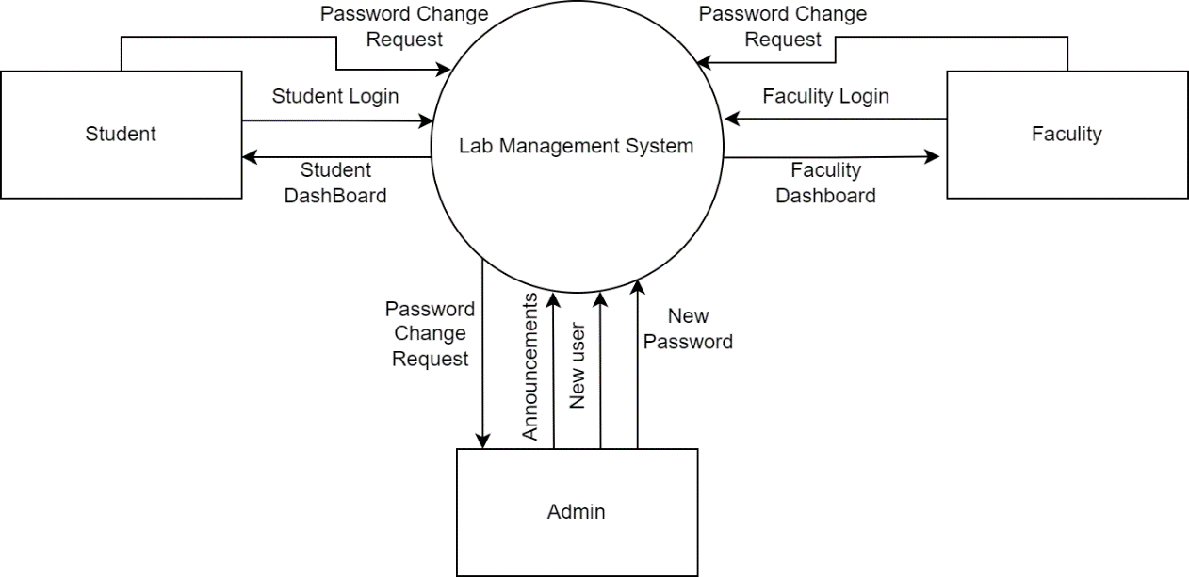

**5.3.1** Data Flow Diagram Level -0

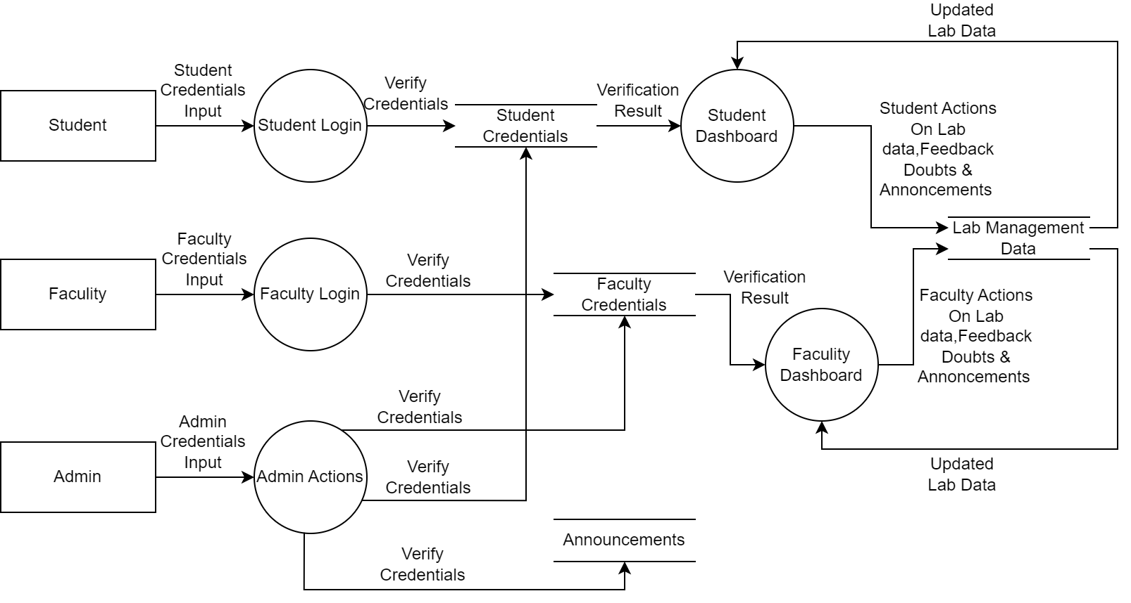

**5.3.2** Data Flow Diagram Level-1

## 5.4 USE CASE DIAGRAM

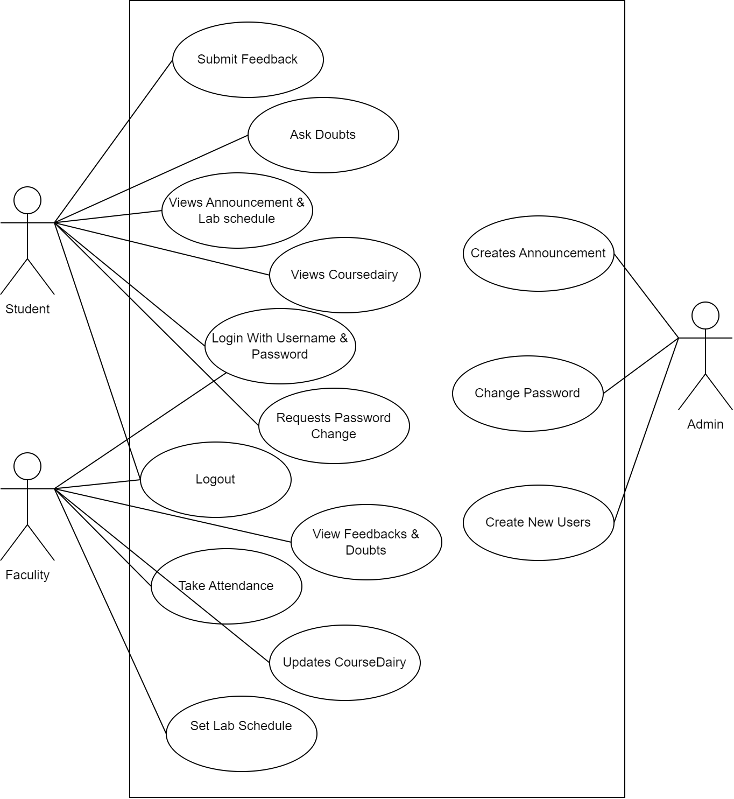

**CHAPTER 5**

# CONCLUSION

In conclusion, the implementation of a lab management system proves to be an invaluable tool for educational institutions seeking to optimize their resources, enhance student engagement, and improve overall academic outcomes. This project underscores the significant benefits of having a centralized platform for managing lab sessions, attendance tracking, and student feedback. By leveraging this system, institutions can efficiently collect, analyze, and act upon feedback from various stakeholders, including faculty and students.

The lab management system streamlines the workflow of lab management, facilitating seamless collaboration among different stakeholders, including faculty members, administrators, and IT personnel. By centralizing scheduling processes, automating attendance tracking, and providing channels for student feedback, the system enhances efficiency, accountability, and communication within the academic environment.

Furthermore, the analysis and reporting capabilities of the system enable institutions to identify areas for improvement, trends in student engagement, and opportunities for innovation. The robust analytics also assist in measuring the effectiveness of implemented changes, providing valuable insights into the impact of curriculum enhancements and resource allocations.

Ultimately, the lab management system plays a pivotal role in fostering a conducive learning environment and promoting academic excellence. By actively responding to faculty and student feedback, institutions can tailor their educational offerings to better meet the needs of their stakeholders, ultimately leading to improved student outcomes and institutional success.

In summary, the implementation of a lab management system empowers educational institutions to streamline operations, enhance student experiences, and achieve their academic goals in a dynamic and ever-evolving educational landscape.

# REFERENCES

**[1] Intelligent Management System Used for Open Lab**:

* Conference Paper
* DOI: [10.1109/ICCSE.2012.6295271](https://ieeexplore.ieee.org/document/6295271/)
* [Published on July 17, 2012](https://ieeexplore.ieee.org/document/6295271/) [1](https://ieeexplore.ieee.org/document/6295271/).

**[2] Analysis of Optimization Method of Laboratory Management System Based on Internet of Things**:

* Conference Paper
* DOI: [10.1109/ACCTCS53867.2022.00070](https://ieeexplore.ieee.org/document/9821013/)
* [Published on July 18, 20222](https://ieeexplore.ieee.org/document/9821013/).

**[3] Laboratory Management System Based on Internet of Things**:

* Conference Paper
* DOI: [10.1109/ICRIS52159.2020.00082](https://ieeexplore.ieee.org/abstract/document/9523959)
* [Published in 20203](https://ieeexplore.ieee.org/abstract/document/9523959).